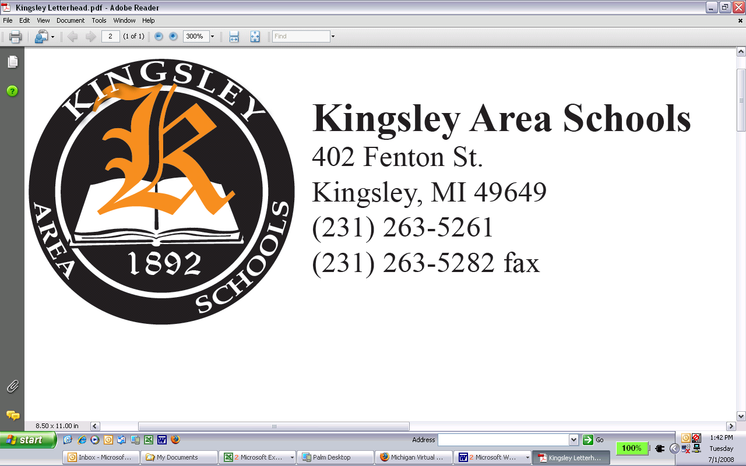
Keith Smith, Superintendent
ksmith@kingsleyschools.org

Mary Bogart, Administrative Assistant
mbogart@kingsleyschools.org

January 19, 2022

Dear Parents and Community Members:

We are pleased to present you with the Annual Education Report (AER), which provides key information on the 2021-22 educational progress for Kingsley Middle School. The AER addresses the complex reporting information required by federal and state laws. The school’s report contains information about student assessment, accountability, and teacher quality. If you have any questions about the AER, please contact Kristin Goethals for assistance.

The AER is available for you to review electronically by visiting the following website Annual Report , or you may review a copy in the main office at your child’s school.

For the 2021-22 school year, schools were identified based on previous years’ performance using definitions and labels as required in the Every Student Succeeds Act (ESSA). A Targeted Support and Improvement (TSI) school is one that had at least one underperforming student subgroup in 2018-19. An Additional Targeted Support (ATS) school is one that had a student subgroup performing at the same level as the lowest 5% of all schools in the state in 2017-18. A Comprehensive Support and Improvement (CSI) school is one whose performance was in the lowest 5% of all schools in the state or had a graduation rate at or below 67% in 2016-17. Some schools are not identified with any of these labels. In these cases, no label is given.

Our school was identified as not having a label.

State law requires that we also report additional information.

PROCESS FOR ASSIGNING PUPILS TO THE SCHOOL
Kingsley Area Schools assigns students to three schools based only on the grade level of each students. All students enrolled in 5th-8th grade who attend as district residents or as school of choice students are assigned to Kingsley Middle School.

STATUS OF THE 3-5 YEAR SCHOOL IMPROVEMENT PLAN
Kingsley Middle School is in full compliance with the Michigan Department of Education school improvement plan model to develop and implement the school improvement plan. The model is provided through MiAssist and is transitioning to the MICIP tool. This allows school to develop goals and strategies to address areas in need of improvement. Kingsley Middle School continues to focus on three areas of strengths in math, reading, and writing.

DESCRIPTION OF EACH SPECIALIZED SCHOOL
Kingsley Middle School is not a specialized school (magnet school, special education, target school, or other)

DESCRIPTION OF THE CORE CURRICULUM & IMPLEMENTATION
In 2010 the Michigan Department of Education adopted a comprehensive set of national standards for English Language Arts and Mathematics or CCSS (Common Core State Standards). The district curriculum council approved a timeline for implementation that includes collaboration with the Traverse Bayt Area Intermediate School District for the purpose of realigning K-12 curriculum from the GLCE’s (Grade Level Content Expectations) to the new CCSS. All grade levels 5-8 began the process of reviewing the new CCSS during the 2010-11 school year and have achieved full implementation. Middle school content area teachers accomplished the critical task of reviewing and aligning the Language Arts and Math standards to the new CCSS by the endo f the 2013 school year. WE will continue with science and social studies as they are release and published. The middle school teaching staff is highly dedicated to a collaborative and purposeful curriculum alignment process. The teaching staff, working in grade level teams, are beginning to engage in realignments by using release days derived from professional development funds. The alignment process includes a systematic process including the following; Review of each area as it is released. Review of new and changing standards. Review of “power standards” or essential standards that are considered to be crucial at each grade level. Determination of the materials that will be required to provide instruction for each standard. Development of packing guides or schedules that outline when instruction will take place Development and review of assessments that will be used to determine student progress. Planning of the specific lessons, vocabulary, and sequence of instruction required to effectively deliver each standard. Development and review of “Essential Objectives” (power standards) for each core area. Publishing an alignment document for every CCSS standard, which includes the strand, standard, essential questions, instruction, and assessments. Publishing a grade level document that identifies essential questions foe ach core area as well as other grade level information. Educators and classroom teacher form Michigan school districts have been involved in the development and/or review of Michigan’s GLCE’s and the new CCSS;’s. The expectations were designed to ensure that students receive seamless instruction, form one grade to the next, leaving no gaps in any child’s education. More importantly, they set high expectations in literacy and mathematics so we can better prepare all K-12 students for the challenges they will face in a global 21st century. A copy of the newly revised CCSS alignments for English Language Arts, grade level alignments, and essential question guides can be obtained by submitting a request to the middle school principal.
AGGREGATE STUDENT ACHIEVEMENT RESULTS
Kingsley Middle School administers NWEA assessments to all students in grades 5-8 in reading and mathematics three times each school year. The results of the assessments are provided to parents at the end of each year. Students are provided with their “target” or “RIT” score before each assessment and are provided with coaching on their growth and improvement. The assessments are also the most critical data that are used to determine if students are struggling and may be in need of intervention.
PARENT/TEACHER CONFERENCES
Kingsley Middle School hold two parent teacher conferences during the school year, in addition to an Open House held in August. The purpose of conferences is to discuss the students’ progress, highlight areas of success, clarify areas of concern, discuss ways to improve those areas, and to strengthen the working relationship between home and school. Over 70% of parents attended their fall scheduled conference meetings. Additional conferences are held throughout the year as requested by teachers, parents, and/or administration.
As you review this report, you will see that Kingsley Middle School has had another successful school year. This success was due to the dedicated staff, supportive community and awesome student body that make up our school. WE plan to continue this tradition by being pro-active in helping meet our individual student’s’ academic needs. WE will continue to utilize NWEA, a computerized student testing system that will allow us to better monitor student achievement. This valuable data will help teachers adjust their teaching strategies thus allowing students to experience more academic growth. We take great pride in working with you to educate our students to become productive, responsible citizens and life-long learners.

Sincerely,

Kristin Goethals, Ed.S, Principal
Kingsley Area Schools

